**Preliminary Results Summary: Evaluating the Effectiveness of COVID-19 Control Measures in Florida (10/17/20)**

**Purpose**

Begin to explore the feasibility of answering the research question, “have state-level COVID control measures had a larger impact on COVID-19 community transmission than county-level control measures, in Florida?” with data that is currently available.

**Descriptive Summary**

The final COVID-19 data set contains observations for 67 counties. The data set starts on March 3rd, 2020, and ends on August 29th, 2020. The data set contains a total of 13,185 observations. The mean daily case count for the sample is 46.63 (see Table 1). Both the county-level case and test count variables contain observations that ranged into negative values, indicating corrective revisions of the surveillance data. The daily COVID-19 case numbers follow a Poisson distribution. This count variable may follow a zero-inflated Poisson distribution.

Table 1 Case count and positive ratio descriptive analysis

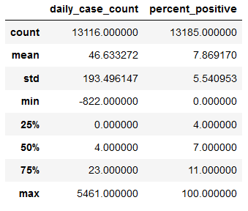

The highest single-day state-level COVID-19 case count was 18,649 cases, which occurred on August 1st. This peak also coincides with the peak in the seven-day rolling mean of COVID-19 case counts peaked (see figure 2).

**Model Summary**

A linear mixed-effects model with random intercepts using county as the unit of analysis was specified to model daily county-level COVID-19 case counts. The random intercept model accounts for the random variation across counties without the need for as many control variables. Without including the county-level random effects more control variables would be needed to account for between-country variance. The control variables added to the model included the county-level population, day of the week, county-level daily testing numbers, and the county-level clinical care rating rank. This ranking ranged from 1-67, with lower values being associated with qualitatively better clinical care.

Also included in the model as, the variables of interest, were select variables from the categorical Oxford COVID-19 Government Response Tracker data set. These variables including school closure and stay at home requirement status. These ordinal variable values ranged from a minimum of zero to a maximum of three. In these COVID-19 control measure variables, zero indicated no control measure implementation, and higher values were associated with a more robust control measure implementation and enforcement.

As anticipated, larger county populations and higher daily testing numbers were associated with higher COVID-19 daily case counts. The categorical day of week value was negatively associated with COVID-19 daily case counts. Interestingly when controlling for all other variables the county-level clinical care ranking was positively associated with daily COVID testing numbers. The state-level stay home requirement level was positively associated with daily COVID-19 case counts. School closure status was negatively associated with daily COVID-19 case counts (see Figure 1). Finally, both phase one and phase two reopening were associated with lower COVID-19 daily case counts. See Table 2 for more details on the model output.

**Discussion and Next Steps**

The negative association between the day of the week and COVID-19 daily case counts indicates that weekdays that fall later in the week (Friday, Saturday, Sunday) are associated with few case reports. This is an important consideration for future efforts to model daily COVID-19 surveillance data in Florida. Further investigation is needed to better interpret the relationship between school closure status and case counts, as a portion of the sample data spans the normal school summer vacation period. The positive relationship between the state-level stay at home order requirement level indicates that as the state implemented more restrictive stay at home requirements case numbers also increase, with the inverse also being true. This is another interesting finding that will need to be investigated and potentially indicates a reactionary process to the change in the stay at home requirement status.

Despite these initial promising results, a good deal of work is still needed to adequately answer the research question under study. The data set will need to be updated to capture the last ~45 days of variance in COVID-19 daily case counts and the relationship between phase 3 reopening and COVID-19 case numbers. Data also needs to be collected on county-level COVID-19 control measures and a methodology needs to be selected to compare these county-level measures to applicable state-level control measures. The negative values in the daily case counts will need to be accounted for in the final analysis. Along with these negative values, data dumps and reporting backlogs that lead to artificially high daily case numbers will also need to be accounted for. The variance daily COVID-19 case count for the sample was over 8 times larger than the mean. This Indicates that a negative binomial model will likely be needed. Finally, further investigation, including modeling the lagged case counts against the independent variables is needed to help shed light on this and other interesting relationships seen in this initial analysis. Lag values of 1-14 days should be evaluated using a distributed lag model.

|  |  |  |  |  |  |  |  |  |  |  |
| --- | --- | --- | --- | --- | --- | --- | --- | --- | --- | --- |
|  | *Table 2. Parameter Estimates for Fixed Effects Random Effects Model* | | | | | | | | |  |
|  | **Effect** |  | **Estimate** |  | **Standard Error** |  | **t Value** |  | **Pr > |t|** |  |
|  | Intercept |  | -12.14 |  | 6.44 |  | -1.89 |  | 0.06 |  |
|  | Day of week |  | -1.47 |  | 0.32 |  | -4.59 |  | **<.0001** |  |
|  | Daily test count |  | 0.20 |  | 0.00 |  | 211.75 |  | **<.0001** |  |
|  | Population |  | 0.00 |  | 0.00 |  | -10.32 |  | **<.0001** |  |
|  | Stay at home |  | 13.57 |  | 1.34 |  | 10.11 |  | **<.0001** |  |
|  | School closing |  | -10.72 |  | 1.61 |  | -6.66 |  | **<.0001** |  |
|  | Clinical care rank |  | 0.53 |  | 0.12 |  | 4.32 |  | **<.0001** |  |
|  |  |  |  |  |  |  |  |  |  |  |

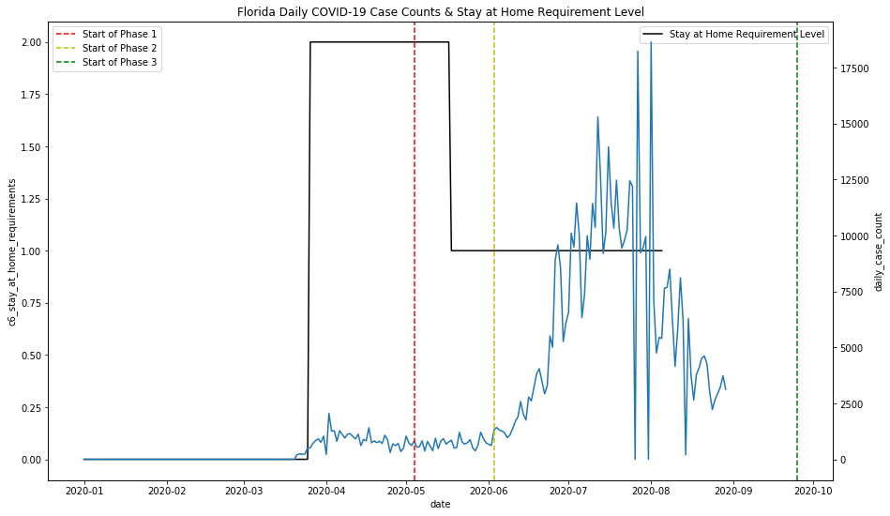

Figure 1 Daily COVID-19 Case Counts Overlayed With the State Stay at Home Requirement Status and Reopening Phase Dates

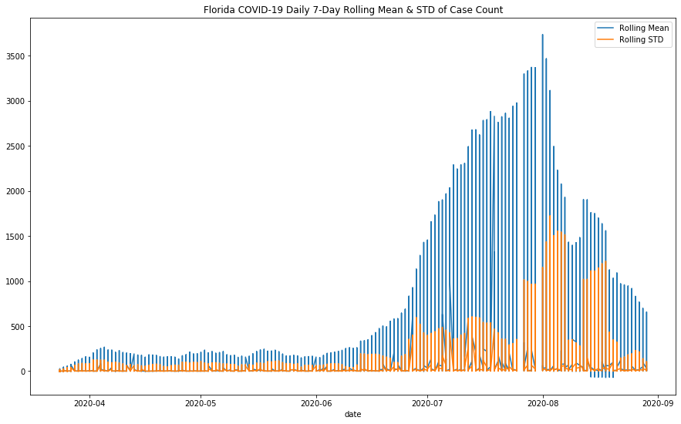

Figure 2 Seven-day Rolling Mean and Standard Deviation for COVID-19 Case Counts